**STATECHART DIAGRAMS FOR TRADE GAME**

**G. SuryaDev Reddy** : 14CO214 : gouru.surya@gmail.com 8123997429

**Yathish Reddy M** : 14CO254 : yathish13mreddy@gmail.com 9448505272

**Srihari B T** : 14CO256 : srihari915@gmail.com 9482947011

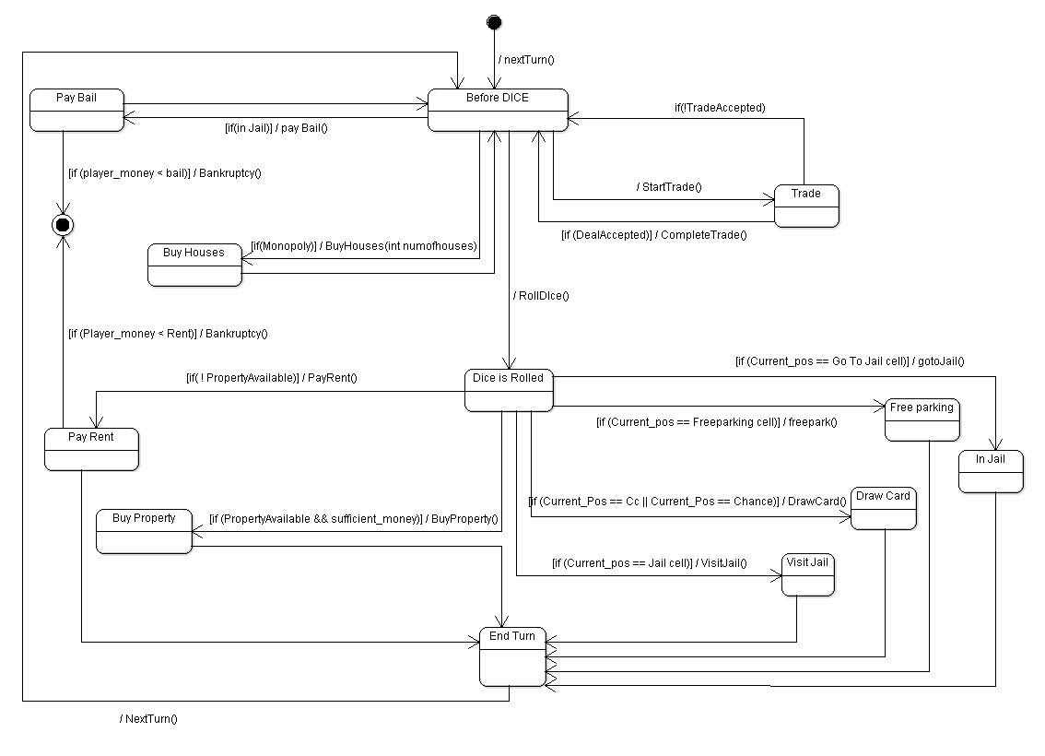

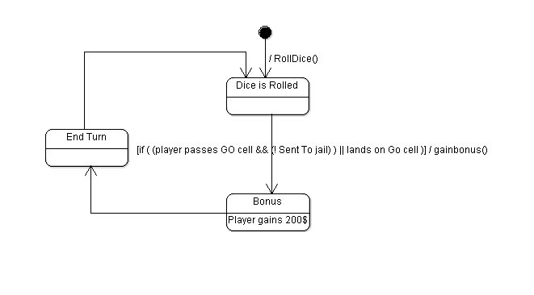

**UC 1 : Pass GO cell**

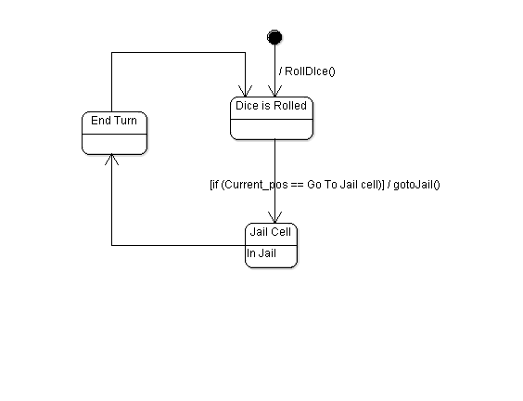

**UC 2 : Go To Jail**

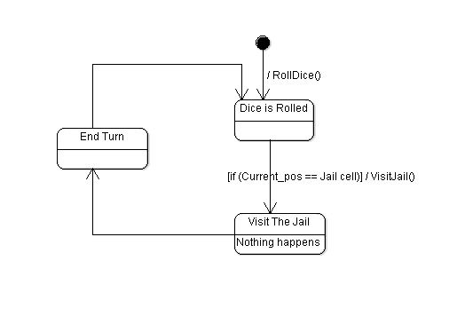

**UC 3 :Visit Jail**

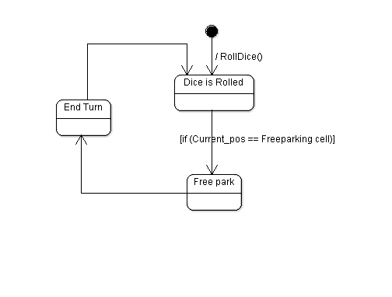

**UC 4 :Go To Free Parking**

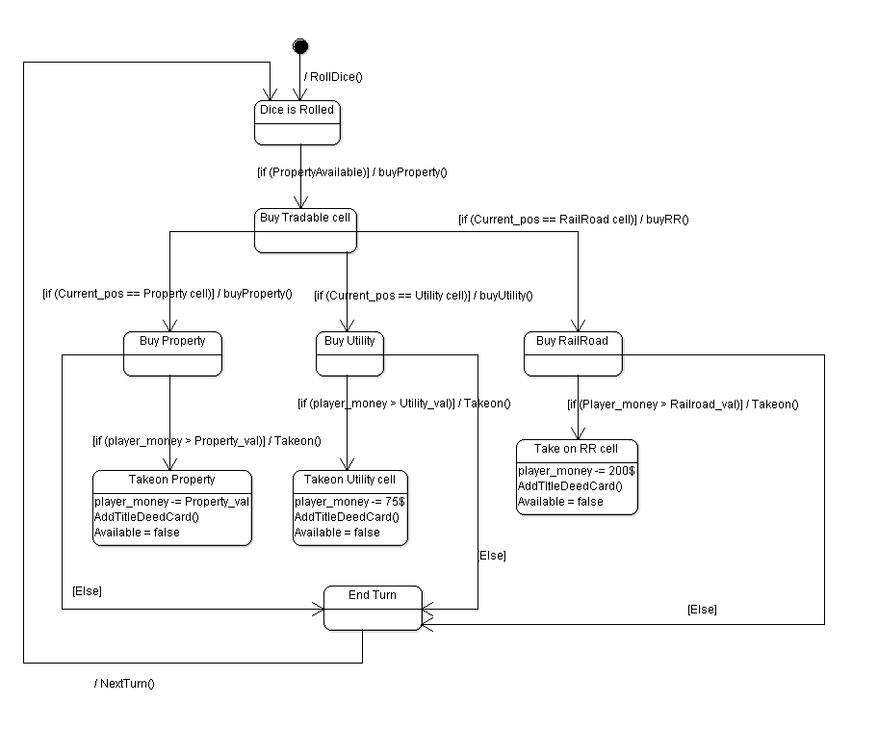

**UC 5: Purchase Property cell**

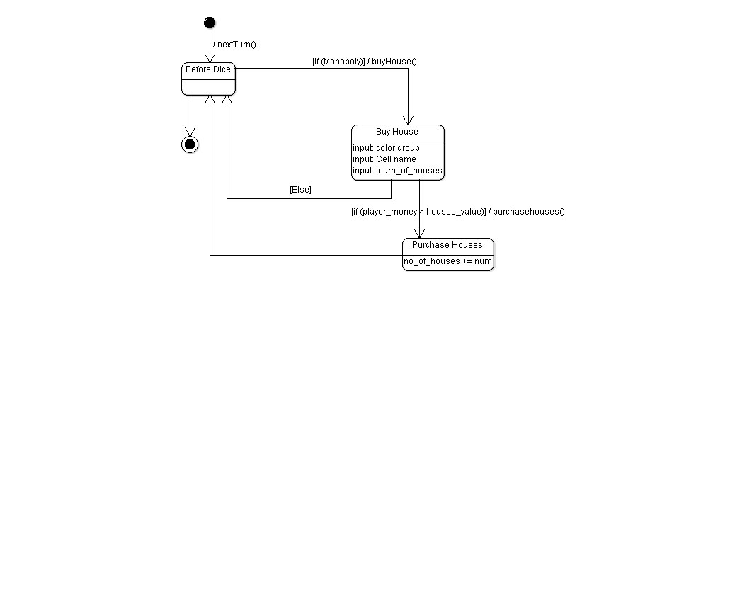**UC 6 :Buy House**

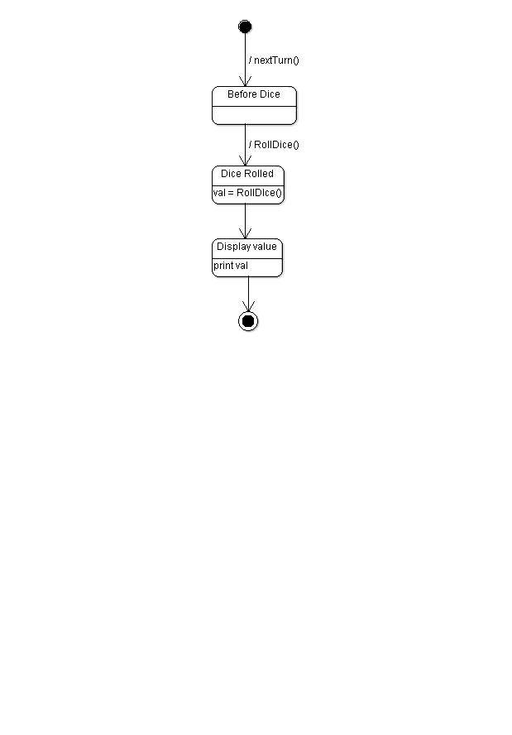

**UC 7: Roll Dice**

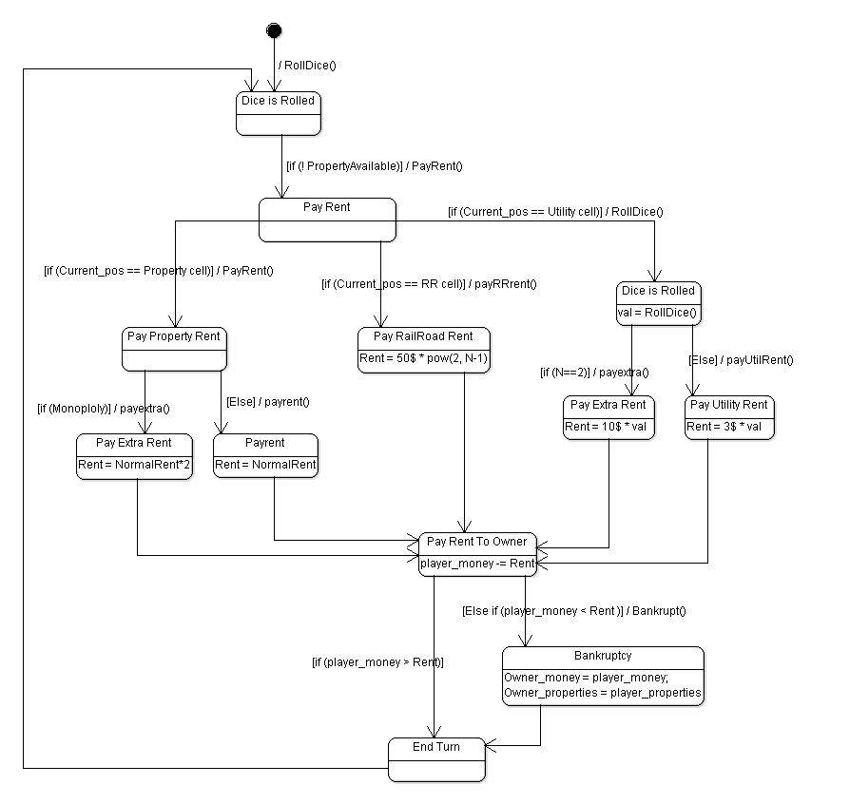**UC 8: Pay Rent**

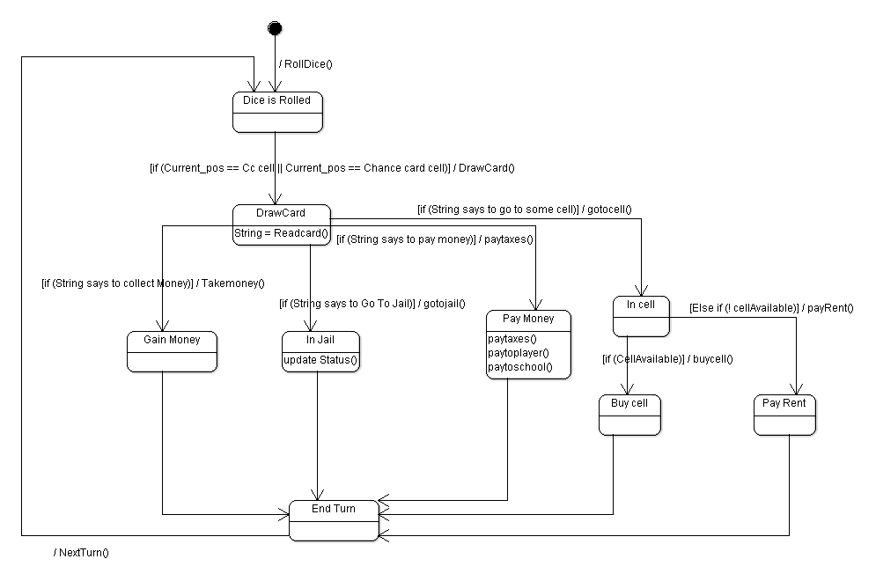

**UC 9: Draw Card**

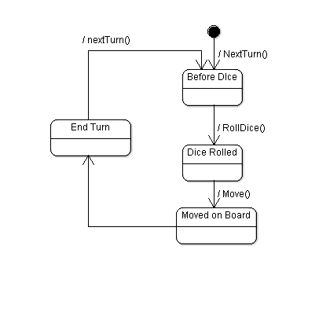

**UC10 : Switch Turn**

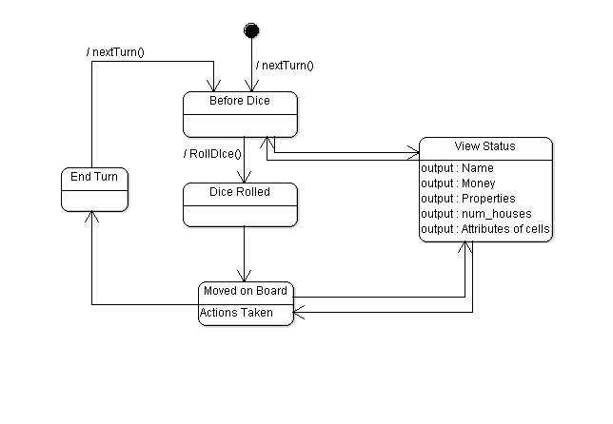

**UC11 : View Information**